
GRP 4492
Treasures of the South
featuring Savannah & Charleston
May 11 – 17, 2026
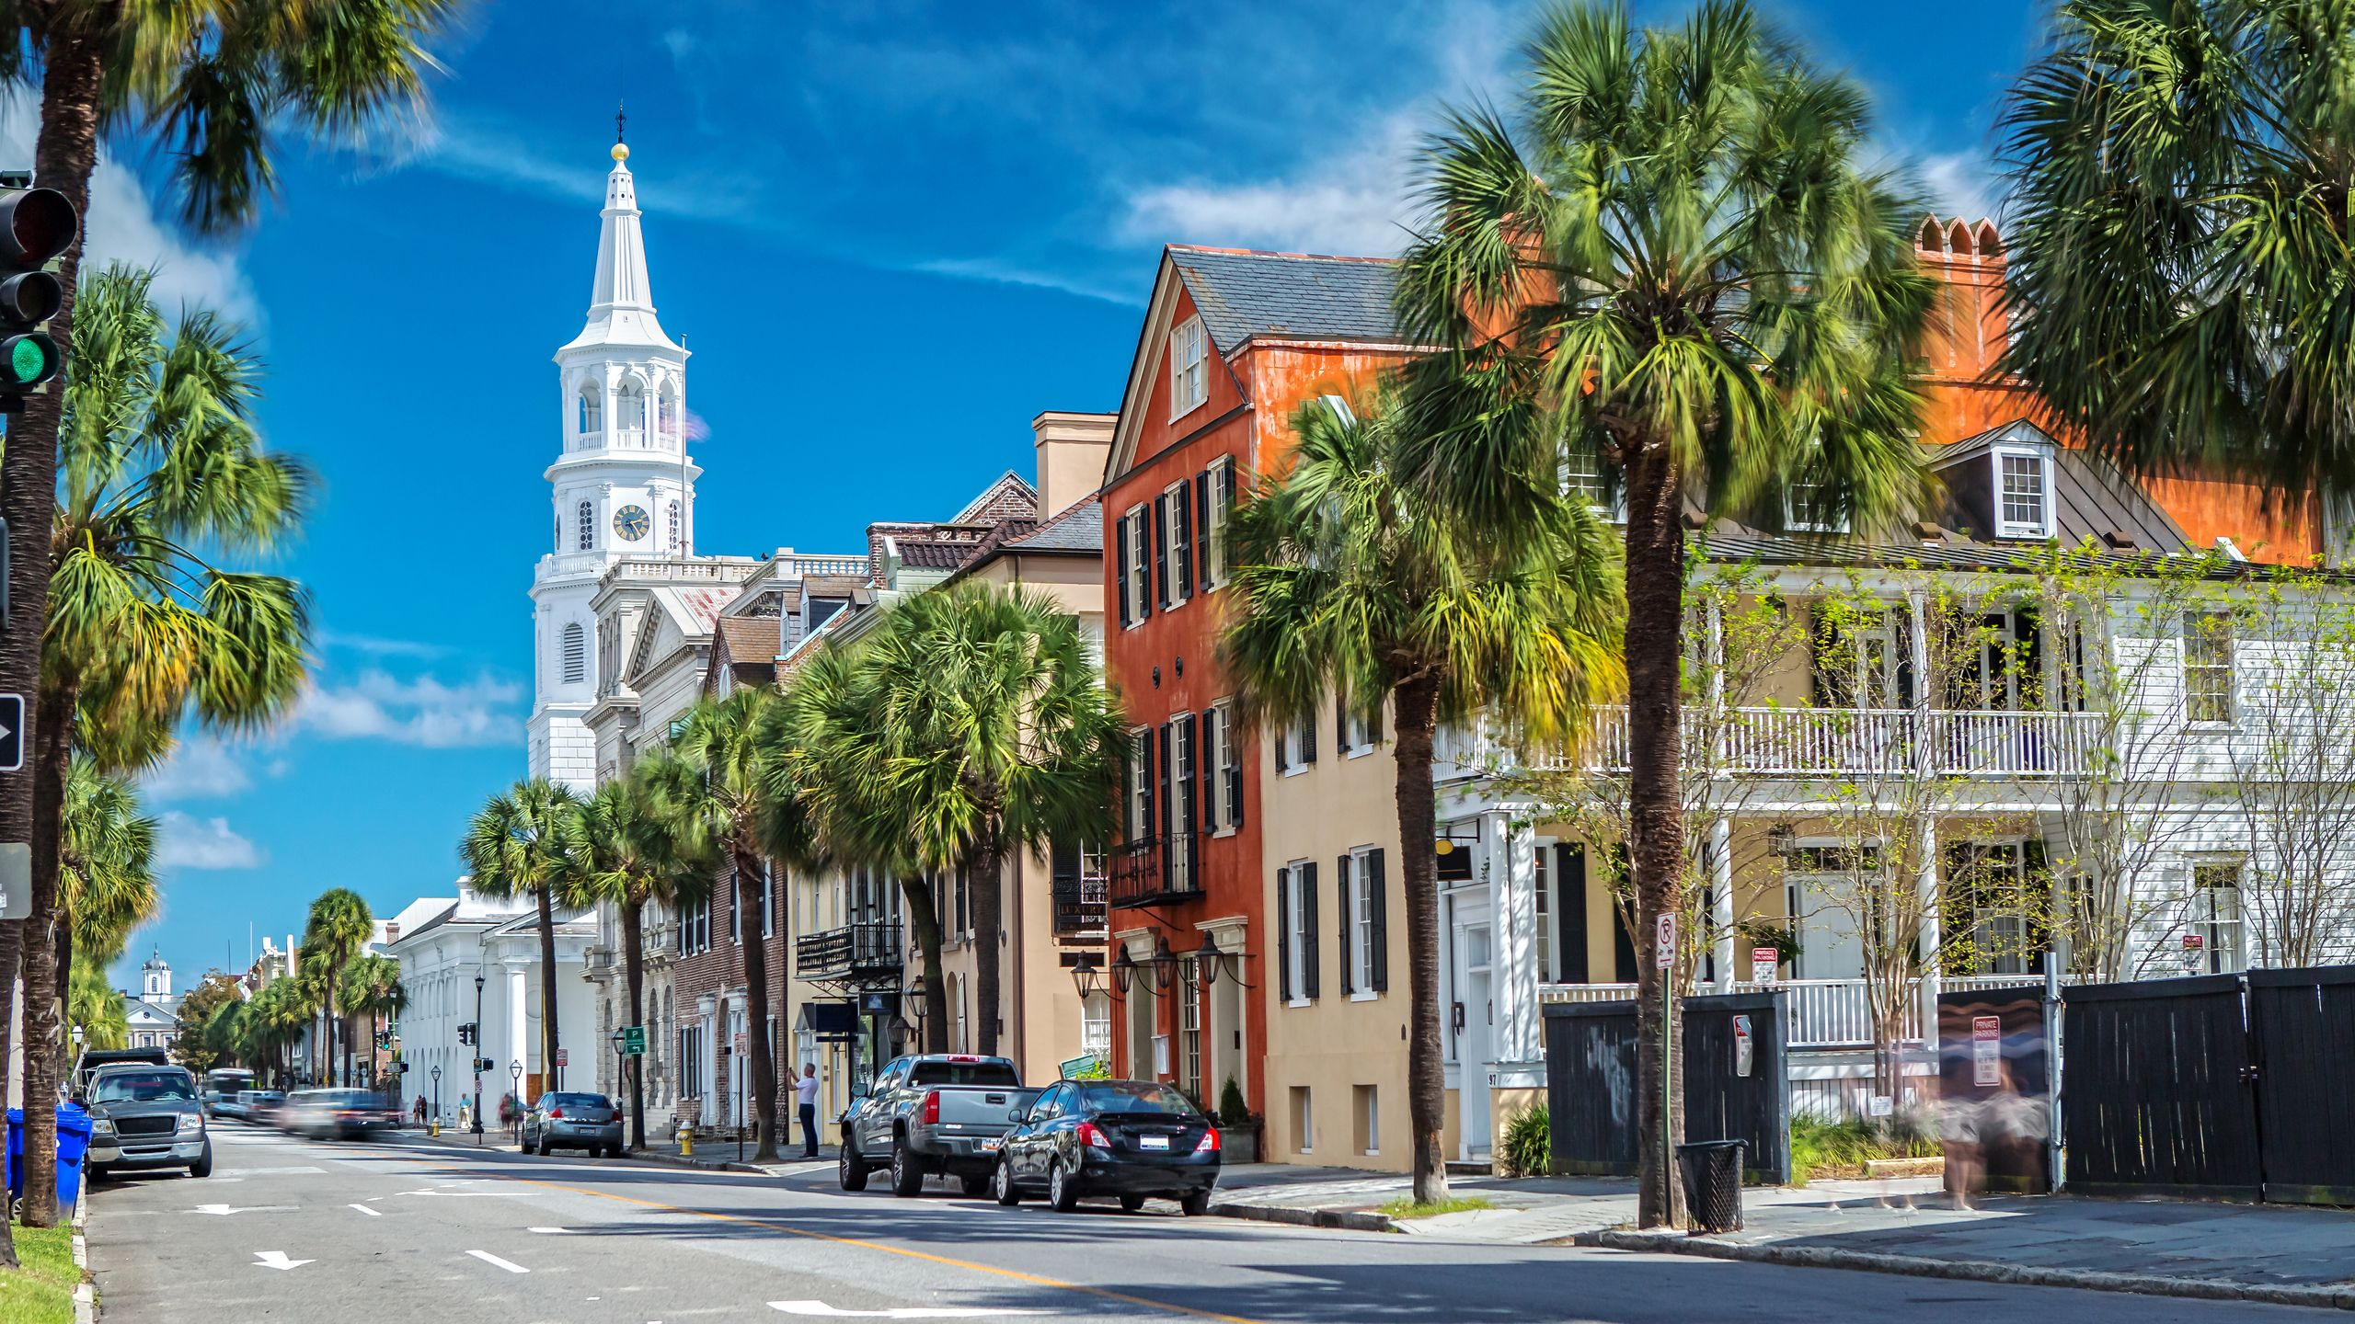
PRICING
Double $2699.00 per person
Single $3635.00 per person

DEPARTURES
AAA, South Williamsport
Quality Inn, New Columbia
AAA, Scranton
Lowes, Stroudsburg
Departure times will be confirmed closer to travel.

NOT INCLUDED
Items of a personal nature
Meals not mentioned
INCLUDED FEATURES & HIGHLIGHTS
- 6 Nights’ Accommodations
- 6 Breakfasts, 4 Dinners
- Guided tour of Historic Savannah
- Savannah River cruise
- Admission to Mercer-Williams House
- Visit to Beaufort
- Carriage rides in Beaufort & Charleston
- Admission to Charleston Tea Plantation
- Guided tour and scenic cruise of Charleston
- Visit to Virginia Beach
- Motorcoach transportation
- Taxes, meal & motorcoach gratuities
- Baggage handling
- AAA Host

Reservations and Cancellations
A $100.00 deposit, per person, is required at the time of making your reservation. If a deposit is not received within 7 days, the reservation will automatically cancel. Final payment is due March 13, 2026. If cancellation should become necessary after final payment, no refund will be due unless your seat can be resold. Cancellation Insurance is strongly recommended. Ask your travel agent for details.
*All prices are based on a minimum number of passengers. If the number falls below that number, the tour may be canceled, or additional costs may apply. Additional fuel surcharges may be imposed at any time by the tour operator, up to and including time of departure that will be the responsibility of the client.
Smoking and Seating Information
No smoking is permitted on the coach. Seats are assigned according to the reception of the reservation. Seats will not be rotated. If you are traveling with another party, require a wheelchair lift, or need to request special seating due a disability, please inform us at the time the reservation is made.

Travel Assistance
AAA regrets that it is not able to provide individual assistance to a tour member for walking, dining or other personal needs. A companion who is capable of and completely responsible for providing it must accompany persons needing such assistance for personal needs.

Guests should consider their physical fitness level and medical history when determining whether this tour is appropriate. Full participation may require extended periods of walking over even and uneven surfaces and steep terrain. There may be steps, inclines, cobblestone surfaces, and extended periods of standing. Participants with physical limitations should take this into account.

Disclaimer of Liability
With respect to the travel arrangements made in connection with this transaction, AAA Travel Agency works with a variety of disclosed principals and independent contractors, including, but not limited to, carriers, cruise lines, transportation companies, tour operators, wholesalers, service companies, hotels, and similar suppliers of travel-related services. AAA Travel agency is not responsible or liable for any acts, omissions, financial stability, delays, changes, use or secure storage of any of your information, personal or otherwise, supplied by you directly or through AAA Travel Agency, by any of the entities of the type listed above. Neither the AAA Travel Agent nor any of its representatives shall be or become liable or responsible for any loss, injury, damage to person, property, or otherwise in connection with any accommodations, transportation, hotel, restaurant, baggage, tour, flight or cruise services resulting directly or indirectly from acts of God, terrorism, social or labor unrest, mechanical or construction failures or difficulties, diseases, bacteria, pathogens, local laws, climatic or weather-related conditions, floods, storms, hurricanes, typhoons, droughts, high or low water levels, criminal acts, fire, breakdown in machinery, acts of governments, de jure or de facto, war, hostilities, civil disturbances, strikes, riots, thefts, epidemics, pandemics, medical quarantines, customs, entry or visa regulations, defaults, delays or cancellations of or changes in itinerary, routing or schedules, from any cause beyond the control of the AAA Travel Agency or from any loss or damage resulting from, missing, lacking, untimely, insufficient or improperly issued passports, visas or other required border-entry documents. Traveler(s) assume complete and full responsibility for checking and verifying any and all passport, visa, vaccination, or other entry requirements of each destination, as well as any and all terms and conditions and restrictions (including, without limitation, fare restrictions) imposed by any carrier, and all safety, health or security conditions at such destinations, during the length of the proposed travel. By embarking upon his/her travel, each traveler voluntarily assumes all risks involved in such travel, whether expected or unexpected. Traveler’s retention of tickets, reservations, or bookings after issuance shall constitute consent to the above, and an agreement on his/her part to convey the contents hereto to all his/her travel companions or group members. The above information is intended to assist you with your travel plans but does not necessarily represent complete and up-to-date travel information for your specific plans.

For reservations, please contact an office below or visit www.aaa.com/appointments.

AAA SCRANTON
570-348-2511

AAA STROUDSBURG
570-421-2500

AAA HONESDALE
570-253-0160
AAA SOUTH WILLIAMSPORT
570-323-8431

AAA WELLSBORO
570-724-4134
AAA TUNKHANNOCK
570-836-5104

AAA TOWANDA
570-265-6122

AAA EAST CENTRAL
570-286-4507

ITINERARY
* This itinerary is subject to change at the tour operator’s discretion without notification and/or compensation.

Day 1 – Monday, May 11
This morning, begin your Treasures of the South Adventure to the cobblestone streets of Savannah and Charleston, where Southern charm, historic architecture, and moss-draped oaks create a storybook setting. Savor the flavors of Lowcountry cuisine, explore beautifully preserved homes and gardens, and feel the warm hospitality that defines these iconic Southern cities. From scenic waterfronts to fascinating tales of the past, Savannah and Charleston offer an unforgettable blend of elegance, culture, and timeless beauty. Tonight, check into your hotel for the evening and enjoy dinner on your own at one of the restaurants nearby.
Hotel (1 nt): Hampton Inn Mount Airy (2029 Rockford St, Mt Airy, NC 27030)

Day 2 – Tuesday, May 12
This morning, after breakfast, we set off for Savannah. This afternoon, welcome to Savannah! Step into a world where southern hospitality flourishes and every street corner reveals a secret waiting to be discovered. Savannah is a jewel in the crown of the South, where its elegant squares come alive with vibrant colors, sharing stories of a rich past. Start your visit off with a 1 ½ hour cruise aboard a Savannah Riverboat Cruise, where you can experience the river that was – and remains – the lifeblood of Savannah! Hear our Captain’s intriguing tales and historical facts about our modern port and the ships that visit worldwide. Take advantage of the great photo opportunities of Savannah’s historic riverfront and skyline. Later, check into your hotel for a two-night stay. Tonight, gather for a delicious dinner at one of the city's acclaimed restaurants.
Hotel (2 nts): Hampton Inn Savannah-Historic District (201 E Bay St, Savannah, GA 31401)
Meals included: B, D

Day 3 – Wednesday, May 13
After breakfast, meet your local guide for a wonderful day of touring Georgia’s “Hostess City.” Begin at Savannah’s Visitors Center to get acquainted with the city before setting off for a city tour. Steeped in history, tradition, and romance, Savannah traces its roots to 1733 when British General James Edward Oglethorpe and 114 British settlers landed on a bluff high above the Savannah River. Your tour will include driving and walking as we view many of its original 21 squares, embraced by ivy-laced homes and buildings, most built during the antebellum period. View notable sites such as Forsyth Park, Savannah’s Squares, Cathedral Basilica of St. John the Baptist, River Street, and much more! Enjoy lunch on your own along the riverfront. This afternoon, visit the Mercer-Williams House. Initially designed for General Hugh Mercer, great-grandfather of songwriter Johnny Mercer, the House was made famous for its role in the movie Midnight in the Garden of Good and Evil. Enjoy dinner this evening at another one of Savannah’s wonderful restaurants!
Meals included: B, D

Day 4 – Thursday, May 14
Enjoy breakfast before checking out and departing for Beaufort, South Carolina, a scenic harbor town overlooking the Beaufort River. Founded over three centuries ago and colonized by the British, Beaufort is renowned for its architecture and antebellum mansions. More recently, this charming town has appeared on the big screen in classic films such as Forrest Gump, The Big Chill, The Great Santini, and The Prince of Tides. Your visit to Beaufort features a Narrated Horse-Drawn Carriage Tour highlighting this southern treasure's rich history and appeal! Enjoy lunch on your own before departure for Wadmalaw Island and the Charleston Tea Plantation. After an informative factory tour, take an educational Trolley Ride through the tea fields. Afterward, enjoy an iced or hot tea and time to browse the gift shop. Before arriving in Charleston, enjoy a photo stop at the famous Angel Oak, a Southern live oak believed to be 400 to 500 years old. This must-see “symbol of Charleston” measures over 66 feet tall, has a circumference of 28 feet, and from tip to tip, its longest branch has a distance of 187 feet. Arrive in Charleston for a two-night stay. Enjoy dinner at one of Historic Charleston’s acclaimed restaurants tonight.
Hotel (2 nts): Hilton Garden Inn Charleston/Mt Pleasant (300 Wingo Way, Mt Pleasant, SC 29464)
Meals included: B, D
Day 5 – Friday, May 15
After breakfast, meet your local guide for a fun-filled day touring Charleston! This port city, founded in 1670, is defined by its cobblestone streets, horse-drawn carriages, and pastel antebellum houses, particularly in the elegant French Quarter and Battery districts. The Battery promenade and Waterfront Park overlook Charleston Harbor, while Fort Sumter, a federal stronghold where the first shots of the Civil War rang out, lies across the water. Enjoy a Horse-Drawn carriage ride in the Historic District, clip-clopping past beautiful sights like Rainbow Row, The Battery, and historic South of Broad homes. This afternoon, enjoy some free time to explore Charleston at our leisure. Later today, enjoy a scenic narrated cruise while enjoying enthralling tales of the city’s colorful past, viewing notable landmarks such as Fort Sumter, the aircraft carrier USS Yorktown, The Battery, the Ravenel Bridge, Castle Pinckney, and other sites from the past and present. Tonight, enjoy another delicious dinner at another one of Charleston’s famed restaurants.
Meals included: B, D

Day 6 – Saturday, May 16
This morning, depart Charleston and head to Virginia Beach, VA. This afternoon, arrive at your hotel and enjoy the balance of the day/evening at leisure to explore and dine at one of the great beachfront restaurants.
Hotel (1 nt): Holiday Inn & Suites Virginia Beach - North (3900 Atlantic Ave, Virginia Beach, VA 23451)
Meals included: B

Day 7 – Sunday, May 17
Enjoy breakfast this morning before departing for home, taking home many wonderful memories of our Treasures of the South Adventure.
Meals included: B

