
Trail of Fallen Heroes #4496
25th Anniversary of Flight 93
September 13, 2026
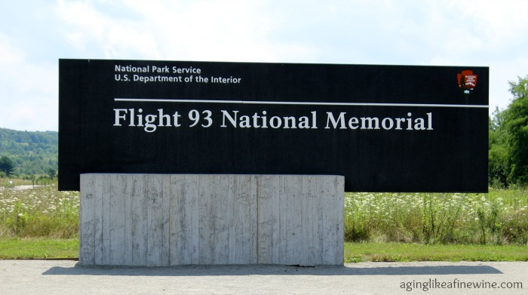
Per Person Price: $169.00

“A common field one day. A field of honor forever.” Twenty-five years ago, September 11, 2001, terrorists attacked the United States by hijacking four commercial airliners and using them as guided bombs. Because of the courage and initiative of her passengers, Flight 93 never reached its target in Washington DC. As passengers struggled to thwart the hijacking the plane crashed into a Western Pennsylvania field. In this field, a monument has been raised to honor the passengers and crew of United Airline Flight 93.
The Trail of Fallen Heroes in Somerset County connects four memorials dedicated to the heroes of Flight 93 and the subsequent Global War on Terrorism. All four memorials honor the bravery, service, and sacrifice of those who died on and after September 11, 2001. All tours are self-guided at each memorial and there is a moderate amount of walking on this tour.
DEPARTURES (Approximate)
AAA, S. Williamsport 6:00AM
Quality Inn, New Columbia 6:30AM

NOT INCLUDED
Items of a personal nature
Meals not mentioned
INCLUDED FEATURES
- Roundtrip motorcoach transportation
- Entry to Flight 93 Memorial Visitor Center
- Tour of Flight 93 National Memorial
Including Tower of Voices and the Memorial Plaza
- Lunch and dessert at Coal Miner’s Diner
- Entry into The Flight 93 Memorial Chapel
- Visit Post 9/11 U.S. Armed Forces Memorial at Patriot Park
- Visit to Remember Me Rose Garden
- Gratuity for motorcoach driver
- Gratuity for included lunch
- AAA Host

Reservations and Cancellations
Payment is due at the time of booking. Should cancellation become necessary, no refunds will be issued unless your seat(s) can be resold. If this trip is cancelled due to weather or other unforeseen events, AAA will make every attempt to re-schedule the trip. If we are not able to reschedule or you cannot travel on the new date, we will issue credit in the amount paid for a future bus trip with AAA North Penn. Refunds cannot be issued. Cancellation Insurance is strongly recommended. Ask your travel agent for details.
All prices are based on a minimum number of passengers. If the number falls below that number, the tour may be canceled, or additional costs may apply. Additional fuel surcharges may be imposed at any time by the tour operator, up to and including the time of departure that will be the responsibility of the client.

Smoking and Seating Information
No smoking is permitted on the coach. Seats are assigned according to the reception of the reservation. Seats will not be rotated. If you are traveling with another party, require a wheelchair lift, or need to request special seating due to a disability, please inform us at the time the reservation is made.

Travel Assistance
AAA regrets that it is not able to provide individual assistance to a tour member for walking, dining, or other personal needs. A companion who is capable of and completely responsible for providing it must accompany people needing such assistance for personal needs. Guests should consider their physical fitness level and medical history when determining whether this tour is appropriate. Full participation may require extended periods of walking over even and uneven surfaces and steep terrain. There may be steps, inclines, cobblestone surfaces, and extended periods of standing. Participants with physical limitations should take this into account.

Disclaimer of Liability
With respect to the travel arrangements made in connection with this transaction, AAA Travel Agency works with a variety of disclosed principals and independent contractors, including, but not limited to, carriers, cruise lines, transportation companies, tour operators, wholesalers, service companies, hotels, and similar suppliers of travel-related services. AAA Travel agency is not responsible or liable for any acts, omissions, financial stability, delays, changes, use or secure storage of any of your information, personal or otherwise, supplied by you directly or through AAA Travel Agency, by any of the entities of the type listed above. Neither the AAA Travel Agent nor any of its representatives shall be or become liable or responsible for any loss, injury, damage to person, property, or otherwise in connection with any accommodations, transportation, hotel, restaurant, baggage, tour, flight or cruise services resulting directly or indirectly from acts of God, terrorism, social or labor unrest, mechanical or construction failures or difficulties, diseases, bacteria, pathogens, local laws, climatic or weather-related conditions, floods, storms, hurricanes, typhoons, droughts, high or low water levels, criminal acts, fire, breakdown in machinery, acts of governments, de jure or de facto, war, hostilities, civil disturbances, strikes, riots, thefts, epidemics, pandemics, medical quarantines, customs, entry or visa regulations, defaults, delays or cancellations of or changes in itinerary, routing or schedules, from any cause beyond the control of the AAA Travel Agency or from any loss or damage resulting from, missing, lacking, untimely, insufficient or improperly issued passports, visas or other required border-entry documents. Traveler(s) assume complete and full responsibility for checking and verifying any and all passport, visa, vaccination, or other entry requirements of each destination, as well as any and all terms and conditions and restrictions (including, without limitation, fare restrictions) imposed by any carrier, and all safety, health or security conditions at such destinations, during the length of the proposed travel. By embarking upon his/her travel, each traveler voluntarily assumes all risks involved in such travel, whether expected or unexpected. Traveler’s retention of tickets, reservations, or bookings after issuance shall constitute consent to the above, and an agreement on his/her part to convey the contents hereto to all his/her travel companions or group members. The above information is intended to assist you with your travel plans but does not necessarily represent complete and up-to-date travel information for your specific plans.

For reservations, please contact an office below or visit.
www.aaa.com/appointments

AAA SCRANTON
570-348-2511

AAA STROUDSBURG
570-421-2500

AAA HONESDALE
570-253-0160
AAA SOUTH WILLIAMSPORT
570-323-8431

AAA WELLSBORO
570-724-4134
AAA TUNKHANNOCK
570-836-5104

AAA TOWANDA
570-265-6122

AAA EAST CENTRAL
570-286-4507

