
GRP 4499
Authentically Vermont
October 5 – 9, 2026

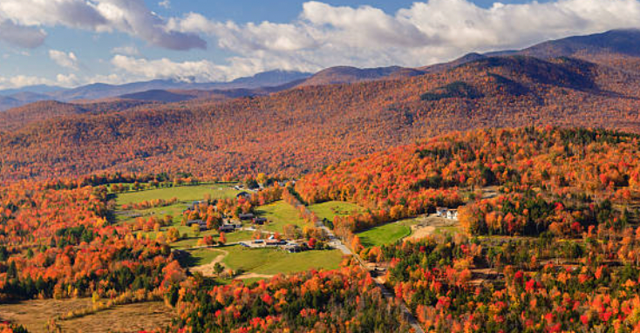

PRICING
Double $2199.00 per person
Single $2959.00 per person

DEPARTURES
AAA, South Williamsport
Quality Inn, New Columbia
AAA, Scranton
Lowes, Stroudsburg
Departure times will be confirmed closer to travel.

NOT INCLUDED
Items of a personal nature
Meals not mentioned
INCLUDED FEATURES & HIGHLIGHTS
- 4 Nights’ Accommodations
- 4 Breakfasts, 3 Dinners, 2 Lunches
- Von Trapp Family Lodge history tour
- Admission/tour of VT Teddy Bear Factory
- Vermont Maple Sugar House experience
- Admission to Billings Farm with private cheese
tasting & wagon ride
- Vermont Country Store visit
- Scenic Gondola/Chairlift ride
- Lake Champlain dinner cruise
- Admission to Hildene
- Motorcoach transportation
- Taxes, meal & motorcoach gratuities
- AAA Host

Reservations and Cancellations
A $100.00 deposit, per person, is required at the time of making your reservation. If a deposit is not received within 7 days, the reservation will automatically cancel. Final payment is due July 24, 2026. If cancellation should become necessary after final payment, no refund will be due unless your seat can be resold. Cancellation Insurance is strongly recommended. Ask your travel agent for details.
*All prices are based on a minimum number of passengers. If the number falls below that number, the tour may be canceled, or additional costs may apply. Additional fuel surcharges may be imposed at any time by the tour operator, up to and including time of departure that will be the responsibility of the client.
Smoking and Seating Information
No smoking is permitted on the coach. Seats are assigned according to the reception of the reservation. Seats will not be rotated. If you are traveling with another party, require a wheelchair lift, or need to request special seating due a disability, please inform us at the time the reservation is made.

Travel Assistance
AAA regrets that it is not able to provide individual assistance to a tour member for walking, dining or other personal needs. A companion who is capable of and completely responsible for providing it must accompany persons needing such assistance for personal needs.

Guests should consider their physical fitness level and medical history when determining whether this tour is appropriate. Full participation may require extended periods of walking over even and uneven surfaces and steep terrain. There may be steps, inclines, cobblestone surfaces, and extended periods of standing. Participants with physical limitations should take this into account.

Disclaimer of Liability
With respect to the travel arrangements made in connection with this transaction, AAA Travel Agency works with a variety of disclosed principals and independent contractors, including, but not limited to, carriers, cruise lines, transportation companies, tour operators, wholesalers, service companies, hotels, and similar suppliers of travel-related services. AAA Travel agency is not responsible or liable for any acts, omissions, financial stability, delays, changes, use or secure storage of any of your information, personal or otherwise, supplied by you directly or through AAA Travel Agency, by any of the entities of the type listed above. Neither the AAA Travel Agent nor any of its representatives shall be or become liable or responsible for any loss, injury, damage to person, property, or otherwise in connection with any accommodations, transportation, hotel, restaurant, baggage, tour, flight or cruise services resulting directly or indirectly from acts of God, terrorism, social or labor unrest, mechanical or construction failures or difficulties, diseases, bacteria, pathogens, local laws, climatic or weather-related conditions, floods, storms, hurricanes, typhoons, droughts, high or low water levels, criminal acts, fire, breakdown in machinery, acts of governments, de jure or de facto, war, hostilities, civil disturbances, strikes, riots, thefts, epidemics, pandemics, medical quarantines, customs, entry or visa regulations, defaults, delays or cancellations of or changes in itinerary, routing or schedules, from any cause beyond the control of the AAA Travel Agency or from any loss or damage resulting from, missing, lacking, untimely, insufficient or improperly issued passports, visas or other required border-entry documents. Traveler(s) assume complete and full responsibility for checking and verifying any and all passport, visa, vaccination, or other entry requirements of each destination, as well as any and all terms and conditions and restrictions (including, without limitation, fare restrictions) imposed by any carrier, and all safety, health or security conditions at such destinations, during the length of the proposed travel. By embarking upon his/her travel, each traveler voluntarily assumes all risks involved in such travel, whether expected or unexpected. Traveler’s retention of tickets, reservations, or bookings after issuance shall constitute consent to the above, and an agreement on his/her part to convey the contents hereto to all his/her travel companions or group members. The above information is intended to assist you with your travel plans but does not necessarily represent complete and up-to-date travel information for your specific plans.

For reservations, please contact an office below or visit www.aaa.com/appointments.

AAA SCRANTON
570-348-2511

AAA STROUDSBURG
570-421-2500

AAA HONESDALE
570-253-0160
AAA SOUTH WILLIAMSPORT
570-323-8431

AAA WELLSBORO
570-724-4134
AAA TUNKHANNOCK
570-836-5104

AAA TOWANDA
570-265-6122

AAA EAST CENTRAL
570-286-4507

ITINERARY
* This itinerary is subject to change at the tour operator’s discretion without notification and/or compensation.

Day 1 – Monday, October 5
This morning, board your luxury motorcoach and depart from select locations, for the beautiful Green Mountains of Vermont. Enjoy the vibrant autumn colors as we make our way north. This afternoon, arrive at your hotel for a lovely two-night stay. Take time to freshen up before gathering for a welcome dinner!
Hotel (2 nts): Doubletree by Hilton Burlington Vermont (870 Williston Rd, S. Burlington, VT 05403)
Meals included: D

Day 2 – Tuesday, October 6
Enjoy breakfast at the hotel and then depart for another spectacular day of touring northern Vermont. Start the morning off with a visit to the Vermont Teddy Bear Factory! Watch as their Bears come to life with hand-swinging, stitching, and stuffing. Then it’s off to the charming village of Stowe! Here we’ll visit the von Trapp Family Lodge for a delicious Austrian-inspired lunch. After lunch, enjoy a History Talk experience that provides insight into the truth and imagined storylines of The Sound of Music, as well as an in-depth look at how the von Trapps escaped Austria and ultimately settled in the beautiful town of Stowe, Vermont. You may even meet a family member and hear about their experiences growing up with Maria! This evening, experience the best of Vermont aboard the Spirit of Ethan Allen's Sunset Dinner Cruise—offering panoramic views of Lake Champlain, the Green Mountains, and the Adirondacks. Savor a chef-prepared buffet featuring fresh, locally-inspired dishes, all while enjoying engaging narration that brings the region's rich history to life. After return to your hotel.
Meals included: B, L, D

Day 3 – Wednesday, October 7
After breakfast, check out of your hotel and set off for another fun-filled day touring around Vermont! Begin with an authentic Maple Experience at one of Vermont’s Maple Sugar Houses. Here you’ll learn about the maple process along with samples of this liquid gold! Then continue to the quintessential New England town of Woodstock for free time and lunch on your own, along with a picture stop at one of Vermont's historic covered bridges. This afternoon, visit one of the finest dairy farms in America and experience farm life in the 1890s at the Billings Farm and Museum. Tour the restored 1890 Farm Manager’s House. Visit with the Jersey cows, sheep, horses, and oxen. Enjoy a wagon ride and take in the scenic landscapes and pastures of the dairy farm. End with a private cheese tasting to sample their award-winning cheddar cheeses! Later this afternoon, arrive and check-in to your hotel before gathering for a delicious dinner together.
Hotel (2 nts): Hampton Inn & Suites Manchester (4519 Main St, Manchester, VT 05255)
Meals included: B, D

Day 4 – Thursday, October 8
After breakfast, visit Weston's charming New England village - home to the Vermont Country Store, founded in 1946. This authentic country store is stocked with thousands of practical and hard-to-find goods and wares that will delight you! Then enjoy a scenic Gondola/Chair Lift ride up one of Vermont’s mountains and enjoy spectacular autumn views of the Green Mountains. Finish the afternoon off with a visit to Hildene, the former summer home of Robert Todd Lincoln, son of Abraham and Mary Lincoln. Tour the restored 24-room Georgian Revival mansion and explore the magnificent gardens. This evening, enjoy a lovely dinner together as a finale.
Meals included: B, D

Day 5 – Friday, October 9
Enjoy breakfast before departing for home taking along wonderful memories of your Authentically Vermont vacation!
Meals included: B

