
GRP 4497
BBQ Trail: Nashville to Memphis
April 19 – 25, 2026
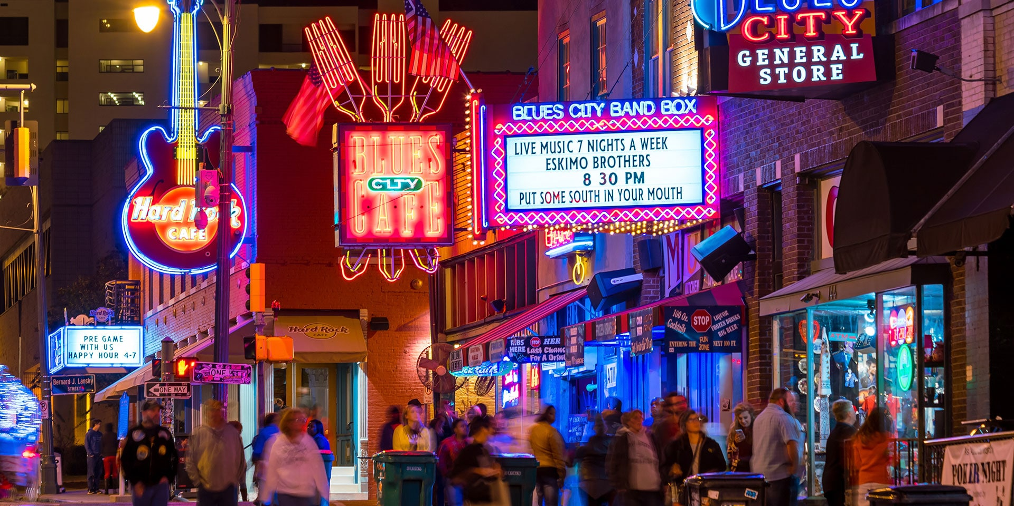

PRICING
Double $1969.00 per person
Single $2659.00 per person

DEPARTURES
AAA, South Williamsport
Quality Inn, New Columbia
AAA, Scranton
Lowes, Stroudsburg
Departure times will be confirmed closer to travel.

NOT INCLUDED
Items of a personal nature
Meals not mentioned
INCLUDED FEATURES & HIGHLIGHTS
- 6 Nights’ Accommodations including overnights
- 6 Breakfasts, 3 Lunches, 2 Dinners
- Tour of the Johnny Cash Museum
- BBQ Foodie Adventure with
Hop-On Mint Julep Experience
- Tour & tasting of local Nashville distillery
- Visit to Stax Museum, Sun Studio and
Edge Motor Museum
- Sightseeing river cruise of Memphis
- LOTS of BBQ!
- Baggage handling
- Motorcoach transportation
- AAA Host
- Taxes, meal & motorcoach gratuities

Reservations and Cancellations
A $100.00 deposit, per person, is required at the time of making your reservation. If a deposit is not received within 7 days, the reservation will automatically cancel. Final payment is due February 6, 2026. If cancellation should become necessary after final payment, no refund will be due unless your seat can be resold. Cancellation Insurance is strongly recommended. Ask your travel agent for details.
*All prices are based on a minimum number of passengers. If the number falls below that number, the tour may be canceled, or additional costs may apply. Additional fuel surcharges may be imposed at any time by the tour operator, up to and including time of departure that will be the responsibility of the client.
Smoking and Seating Information
No smoking is permitted on the coach. Seats are assigned according to the reception of the reservation. Seats will not be rotated. If you are traveling with another party, require a wheelchair lift, or need to request special seating due a disability, please inform us at the time the reservation is made.

Travel Assistance
AAA regrets that it is not able to provide individual assistance to a tour member for walking, dining or other personal needs. A companion who is capable of and completely responsible for providing it must accompany persons needing such assistance for personal needs.

Guests should consider their physical fitness level and medical history when determining whether this tour is appropriate. Full participation may require extended periods of walking over even and uneven surfaces and steep terrain. There may be steps, inclines, cobblestone surfaces, and extended periods of standing. Participants with physical limitations should take this into account.

Disclaimer of Liability
With respect to the travel arrangements made in connection with this transaction, AAA Travel Agency works with a variety of disclosed principals and independent contractors, including, but not limited to, carriers, cruise lines, transportation companies, tour operators, wholesalers, service companies, hotels, and similar suppliers of travel-related services. AAA Travel agency is not responsible or liable for any acts, omissions, financial stability, delays, changes, use or secure storage of any of your information, personal or otherwise, supplied by you directly or through AAA Travel Agency, by any of the entities of the type listed above. Neither the AAA Travel Agent nor any of its representatives shall be or become liable or responsible for any loss, injury, damage to person, property, or otherwise in connection with any accommodations, transportation, hotel, restaurant, baggage, tour, flight or cruise services resulting directly or indirectly from acts of God, terrorism, social or labor unrest, mechanical or construction failures or difficulties, diseases, bacteria, pathogens, local laws, climatic or weather-related conditions, floods, storms, hurricanes, typhoons, droughts, high or low water levels, criminal acts, fire, breakdown in machinery, acts of governments, de jure or de facto, war, hostilities, civil disturbances, strikes, riots, thefts, epidemics, pandemics, medical quarantines, customs, entry or visa regulations, defaults, delays or cancellations of or changes in itinerary, routing or schedules, from any cause beyond the control of the AAA Travel Agency or from any loss or damage resulting from, missing, lacking, untimely, insufficient or improperly issued passports, visas or other required border-entry documents. Traveler(s) assume complete and full responsibility for checking and verifying any and all passport, visa, vaccination, or other entry requirements of each destination, as well as any and all terms and conditions and restrictions (including, without limitation, fare restrictions) imposed by any carrier, and all safety, health or security conditions at such destinations, during the length of the proposed travel. By embarking upon his/her travel, each traveler voluntarily assumes all risks involved in such travel, whether expected or unexpected. Traveler’s retention of tickets, reservations, or bookings after issuance shall constitute consent to the above, and an agreement on his/her part to convey the contents hereto to all his/her travel companions or group members. The above information is intended to assist you with your travel plans but does not necessarily represent complete and up-to-date travel information for your specific plans.

For reservations, please contact an office below or visit www.aaa.com/appointments.

AAA SCRANTON
570-348-2511

AAA STROUDSBURG
570-421-2500

AAA HONESDALE
570-253-0160
AAA SOUTH WILLIAMSPORT
570-323-8431

AAA WELLSBORO
570-724-4134
AAA TUNKHANNOCK
570-836-5104

AAA TOWANDA
570-265-6122

AAA EAST CENTRAL
570-286-4507

ITINERARY * This itinerary is subject to change at the tour operator’s discretion without notification and/or compensation.

Day 1 – Sunday, April 19
A morning departure from your hometown has you traveling to your overnight lodging in Wytheville, VA. Dinner is on your own this evening.
Hotel (1 nt): Fairfield Inn & Suites Wytheville (200 Marriott Way, Wytheville, VA 24382)
Meals included: N/A

Day 2 – Monday, April 20
Following breakfast, check out and continue traveling to Nashville – the Home of Country Music! Upon arrival, you will proceed downtown for a self-guided tour of the Johnny Cash Museum, which honors the life and music of the country superstar often referred to as the “Man in Black”. After your visit, depart for your hotel to check-in. You will have time to freshen up before departing for a BBQ dinner at Central BBQ. After dinner, enjoy free time exploring downtown Nashville and Honky Tonk Row.
Hotel (2 nts): Holiday Inn Express Nashville Downtown-Broadway (920 Broadway, Nashville, TN 37203)
Meals included: B, D

Day 3 – Tuesday, April 21
After breakfast this morning, depart with your local guide for a Hop-On Mint Julep Experience for a BBQ Foodie Adventure. Learn the stories behind some of Nashville’s most popular BBQ and drinking destinations! You will go behind the scenes to get a taste of the best Southern BBQ. This tasting experience will have you immersing yourself in the Tennessee whiskey traditions at a local distillery with a tour and tasting. You’ll also be visiting a local Nashville BBQ joint for a smoked-meat platter and a stop at a brewery for a beer flight. The evening is free to enjoy dinner on your own at one of Nashville’s popular restaurants.
Meals included: B, L

Day 4 – Wednesday, April 22
Enjoy breakfast at the hotel, then check out and travel to Memphis. Lunch will be at Charlie Vergos Rendezvous. This afternoon, you will visit the Stax Museum which is dedicated to soul music and celebrates the legacy of Stax Records and its artists such as Isaac Hayes, Otis Redding, the Staple Singers and Booker T. After your visit, check into your hotel in downtown Memphis. Enjoy free time this evening for dinner on your own and exploring Beale Street.
Hotel (2 nts): Courtyard Memphis Downtown (75 Jefferson Ave, Memphis, TN 38103)
Meals included: B, L

Day 5 – Thursday, April 23
After breakfast, you will visit Sun Studio, the birthplace of Rock ‘n’ Roll, where Elvis, Jerry Lee Lewis, BB King, Johnny Cash, Carl Perkins and Roy Orbison launched their careers! Visit the Sun Studio Café and the Music Museum/Gallery, too. Afterwards, tour the Edge Motor Museum which explores the history of the American sports car. Continue to a BBQ restaurant for a delicious lunch. This afternoon, enjoy a sightseeing cruise of Memphis, down the mighty Mississippi River, with live historical commentary and great views. Your day will end at Kings Palace Café on Beale Street where you will enjoy dinner with Blues entertainment. After, return to your hotel for the evening.
Meals included: B, L, D

Day 6 – Friday, April 24
Enjoy breakfast, then check out and travel to Dayton, OH, for your overnight lodging. Dinner is on your own this evening.
Hotel (1 nt): Fairfield Inn & Suites Dayton North (7072 York Center Dr, Dayton, OH 45414)
Meals included: B

Day 7 – Saturday, April 25
Following breakfast, check out and depart for home with fond memories of your trip to Tennessee! Meals: B

