
GRP 4495
Holland Tulip Festival
May 4 – 8, 2026
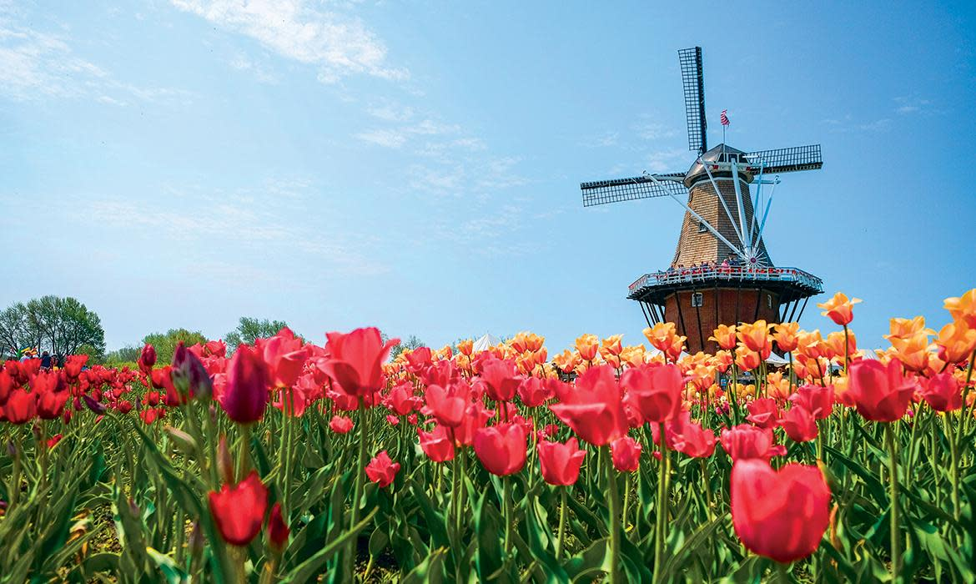

PRICING
Double $1099.00 per person
Single $1505.00 per person

DEPARTURES
AAA, South Williamsport
Quality Inn, New Columbia
AAA, Scranton
Lowes, Stroudsburg
Departure times will be confirmed closer to travel.

NOT INCLUDED
Items of a personal nature
Meals not mentioned
INCLUDED FEATURES & HIGHLIGHTS
- 4 Nights’ Accommodations including overnights
- 4 Breakfasts, 2 Dinners
- Veldheer’s Tulip Gardens
- Dutch Village
- DeKlomp Wooden Shoe & Delft Factory
- Windmill Gardens & DeZwaan Windmill
- Evening revue show
- Guided tour of Holland, Michigan
- Baggage handling
- Motorcoach transportation
- AAA Host
- Taxes, meal & motorcoach gratuities

Reservations and Cancellations
A $100.00 deposit, per person, is required at the time of making your reservation. If a deposit is not received within 7 days, the reservation will automatically cancel. Final payment is due February 20, 2026. If cancellation should become necessary after final payment, no refund will be due unless your seat can be resold. Cancellation Insurance is strongly recommended. Ask your travel agent for details.
*All prices are based on a minimum number of passengers. If the number falls below that number, the tour may be canceled, or additional costs may apply. Additional fuel surcharges may be imposed at any time by the tour operator, up to and including time of departure that will be the responsibility of the client.
Smoking and Seating Information
No smoking is permitted on the coach. Seats are assigned according to the reception of the reservation. Seats will not be rotated. If you are traveling with another party, require a wheelchair lift, or need to request special seating due a disability, please inform us at the time the reservation is made.

Travel Assistance
AAA regrets that it is not able to provide individual assistance to a tour member for walking, dining or other personal needs. A companion who is capable of and completely responsible for providing it must accompany persons needing such assistance for personal needs.

Guests should consider their physical fitness level and medical history when determining whether this tour is appropriate. Full participation may require extended periods of walking over even and uneven surfaces and steep terrain. There may be steps, inclines, cobblestone surfaces, and extended periods of standing. Participants with physical limitations should take this into account.

Disclaimer of Liability
With respect to the travel arrangements made in connection with this transaction, AAA Travel Agency works with a variety of disclosed principals and independent contractors, including, but not limited to, carriers, cruise lines, transportation companies, tour operators, wholesalers, service companies, hotels, and similar suppliers of travel-related services. AAA Travel agency is not responsible or liable for any acts, omissions, financial stability, delays, changes, use or secure storage of any of your information, personal or otherwise, supplied by you directly or through AAA Travel Agency, by any of the entities of the type listed above. Neither the AAA Travel Agent nor any of its representatives shall be or become liable or responsible for any loss, injury, damage to person, property, or otherwise in connection with any accommodations, transportation, hotel, restaurant, baggage, tour, flight or cruise services resulting directly or indirectly from acts of God, terrorism, social or labor unrest, mechanical or construction failures or difficulties, diseases, bacteria, pathogens, local laws, climatic or weather-related conditions, floods, storms, hurricanes, typhoons, droughts, high or low water levels, criminal acts, fire, breakdown in machinery, acts of governments, de jure or de facto, war, hostilities, civil disturbances, strikes, riots, thefts, epidemics, pandemics, medical quarantines, customs, entry or visa regulations, defaults, delays or cancellations of or changes in itinerary, routing or schedules, from any cause beyond the control of the AAA Travel Agency or from any loss or damage resulting from, missing, lacking, untimely, insufficient or improperly issued passports, visas or other required border-entry documents. Traveler(s) assume complete and full responsibility for checking and verifying any and all passport, visa, vaccination, or other entry requirements of each destination, as well as any and all terms and conditions and restrictions (including, without limitation, fare restrictions) imposed by any carrier, and all safety, health or security conditions at such destinations, during the length of the proposed travel. By embarking upon his/her travel, each traveler voluntarily assumes all risks involved in such travel, whether expected or unexpected. Traveler’s retention of tickets, reservations, or bookings after issuance shall constitute consent to the above, and an agreement on his/her part to convey the contents hereto to all his/her travel companions or group members. The above information is intended to assist you with your travel plans but does not necessarily represent complete and up-to-date travel information for your specific plans.

For reservations, please contact an office below or visit www.aaa.com/appointments.

AAA SCRANTON
570-348-2511

AAA STROUDSBURG
570-421-2500

AAA HONESDALE
570-253-0160
AAA SOUTH WILLIAMSPORT
570-323-8431

AAA WELLSBORO
570-724-4134
AAA TUNKHANNOCK
570-836-5104

AAA TOWANDA
570-265-6122

AAA EAST CENTRAL
570-286-4507

ITINERARY
* This itinerary is subject to change at the tour operator’s discretion without notification and/or compensation.

Day 1 – Monday, May 4
A morning departure from your hometown has you traveling to your first overnight lodging. Dinner is on your own this evening.
Hotel (1 nt): TBD
Meals included: N/A

Day 2 – Tuesday, May 5
After breakfast at the hotel, check out and depart for Holland, Michigan, for the annual Holland Tulip Time Festival. Tulips came to Holland, Michigan with Dutch settlers. In 1927, a biology teacher for Holland High School recommended a day festival at a Woman's Literary Club meeting. The idea caught on and the city sold bulbs for a penny to residents in 1928, resulting in the first Tulip Time event in 1929. Arrive in the early afternoon to enjoy lunch on your own in the area. After, visit Dutch Village where you will see Dutch folk dancing, wooden shoe carving, Amsterdam street organs and, of course, tulips! Nelis’ Dutch Village plant over 30,000 bulbs each year for the Tulip Time Festival. Live entertainment is continuous throughout the day. Enjoy dinner this evening at a local restaurant. Following dinner, check into your hotel and relax for the night.
Hotel (2 nts): Holiday Inn Express Holland (12381 Felch St, Holland, MI 49424)
Meals included: B, D

Day 3 – Wednesday, May 6
This morning, following breakfast at the hotel, visit the Veldheer Tulip Gardens, Holland’s only tulip farm perennial garden. In 1950, Vern Veldheer started a hobby farm with 100 red tulips and 300 white tulips. Today, Veldheers plants over 5 million tulips for you to walk through and enjoy! Here, you will also visit the DeKlomp Wooden Shoe & Delft Factory where you can watch craftsmen carve wooden shoes by both hand and machine as well as view the famous Dutch pottery. DeKlomp is the only production facility in North America, offering over 400 different hand-painted Dutch pottery items.
Following lunch on your own, meet your Dutch-costumed guide for a tour that includes Holland’s historic areas, city parks, Hope College, Tulip Lands and downtown Holland. After your tour, enjoy dinner in the area. This evening, enjoy a spectacular show before returning to your hotel.
Meals included: B, D

Day 4 – Thursday, May 7
Following breakfast, check out of your hotel and spend the morning at the Windmill Island Gardens. The gardens are home to the last working windmill allowed to leave the Netherlands in 1964. The historic windmill 'de Zwaan' (meaning graceful bird) is the highlight of the park and stands amongst 36 acres of exhibits, gardens and natural areas. The mill still turns and grinds grain into flour and a tour up 5 floors is the highlight of any visit to the park. Afterwards, depart for your last night of lodging where you will enjoy dinner and some free time before you check in to your hotel.
Hotel (1 nt): TBD
Meals included: B

Day 5 – Friday, May 8
Following breakfast, check out and depart for home with lasting memories of the Holland Tulip Time Festival!
Meals included: B

