
GRP 4476
A Historic Virginia Getaway
featuring the Virginia Scenic Railway
July 15 – 18, 2026
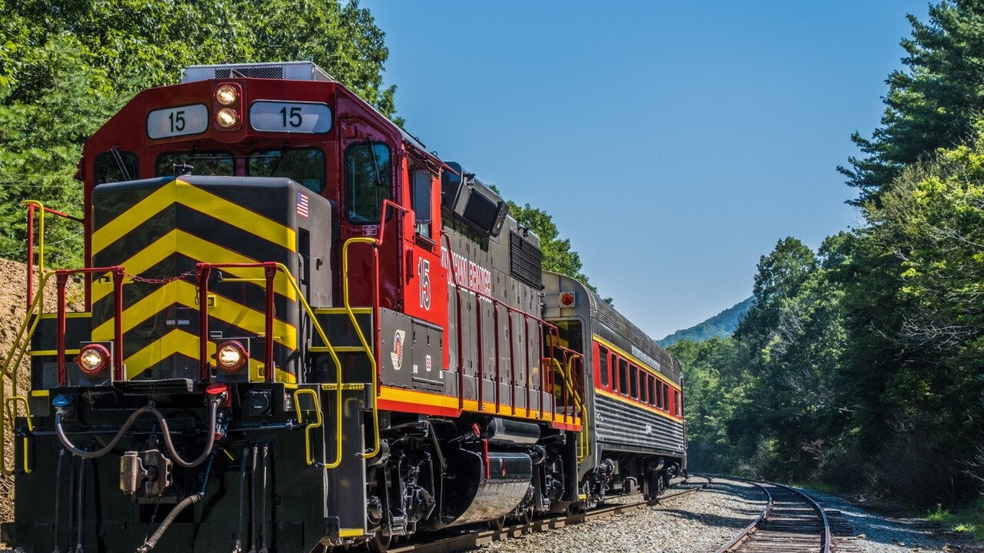

PRICING
Double $1239.00 per person
Single $1539.00 per person

DEPARTURES
AAA, South Williamsport
Quality Inn, New Columbia
AAA, Scranton
Lowes, Stroudsburg
Departure times will be confirmed closer to travel.

NOT INCLUDED
Items of a personal nature
Meals not mentioned
INCLUDED FEATURES & HIGHLIGHTS
- 3 Nights’ Accommodations
- 3 Breakfasts, 2 Lunches, 2 Dinners
- Virginia Scenic Railway train ride
- Thomas Jefferson’s Monticello estate
- James Monroe’s Highland estate
- Wine tasting at a local winery
- Performance at the Blackfriars Playhouse
- Visit Woodrow Wilson Presidential Library & Museum
- Baggage handling
- Motorcoach transportation
- AAA Host
- Taxes, meal & motorcoach gratuities

Reservations and Cancellations
A $100.00 deposit, per person, is required at the time of making your reservation. If a deposit is not received within 7 days, the reservation will automatically cancel. Final payment is due April 30, 2026. If cancellation should become necessary after final payment, no refund will be due unless your seat can be resold. Cancellation Insurance is strongly recommended. Ask your travel agent for details.
*All prices are based on a minimum number of passengers. If the number falls below that number, the tour may be canceled, or additional costs may apply. Additional fuel surcharges may be imposed at any time by the tour operator, up to and including time of departure that will be the responsibility of the client.
Smoking and Seating Information
No smoking is permitted on the coach. Seats are assigned according to the reception of the reservation. Seats will not be rotated. If you are traveling with another party, require a wheelchair lift, or need to request special seating due a disability, please inform us at the time the reservation is made.

Travel Assistance
AAA regrets that it is not able to provide individual assistance to a tour member for walking, dining or other personal needs. A companion who is capable of and completely responsible for providing it must accompany persons needing such assistance for personal needs.

Guests should consider their physical fitness level and medical history when determining whether this tour is appropriate. Full participation may require extended periods of walking over even and uneven surfaces and steep terrain. There may be steps, inclines, cobblestone surfaces, and extended periods of standing. Participants with physical limitations should take this into account.

Disclaimer of Liability
With respect to the travel arrangements made in connection with this transaction, AAA Travel Agency works with a variety of disclosed principals and independent contractors, including, but not limited to, carriers, cruise lines, transportation companies, tour operators, wholesalers, service companies, hotels, and similar suppliers of travel-related services. AAA Travel agency is not responsible or liable for any acts, omissions, financial stability, delays, changes, use or secure storage of any of your information, personal or otherwise, supplied by you directly or through AAA Travel Agency, by any of the entities of the type listed above. Neither the AAA Travel Agent nor any of its representatives shall be or become liable or responsible for any loss, injury, damage to person, property, or otherwise in connection with any accommodations, transportation, hotel, restaurant, baggage, tour, flight or cruise services resulting directly or indirectly from acts of God, terrorism, social or labor unrest, mechanical or construction failures or difficulties, diseases, bacteria, pathogens, local laws, climatic or weather-related conditions, floods, storms, hurricanes, typhoons, droughts, high or low water levels, criminal acts, fire, breakdown in machinery, acts of governments, de jure or de facto, war, hostilities, civil disturbances, strikes, riots, thefts, epidemics, pandemics, medical quarantines, customs, entry or visa regulations, defaults, delays or cancellations of or changes in itinerary, routing or schedules, from any cause beyond the control of the AAA Travel Agency or from any loss or damage resulting from, missing, lacking, untimely, insufficient or improperly issued passports, visas or other required border-entry documents. Traveler(s) assume complete and full responsibility for checking and verifying any and all passport, visa, vaccination, or other entry requirements of each destination, as well as any and all terms and conditions and restrictions (including, without limitation, fare restrictions) imposed by any carrier, and all safety, health or security conditions at such destinations, during the length of the proposed travel. By embarking upon his/her travel, each traveler voluntarily assumes all risks involved in such travel, whether expected or unexpected. Traveler’s retention of tickets, reservations, or bookings after issuance shall constitute consent to the above, and an agreement on his/her part to convey the contents hereto to all his/her travel companions or group members. The above information is intended to assist you with your travel plans but does not necessarily represent complete and up-to-date travel information for your specific plans.

For reservations, please contact an office below or visit www.aaa.com/appointments.

AAA SCRANTON
570-348-2511

AAA STROUDSBURG
570-421-2500

AAA HONESDALE
570-253-0160
AAA SOUTH WILLIAMSPORT
570-323-8431

AAA WELLSBORO
570-724-4134
AAA TUNKHANNOCK
570-836-5104

AAA TOWANDA
570-265-6122

AAA EAST CENTRAL
570-286-4507

ITINERARY
* This itinerary is subject to change at the tour operator’s discretion without notification and/or compensation.

Day 1 – Wednesday, July 15
A morning departure from your hometown has you traveling to Staunton, VA where you will check into your hotel for a three-night stay. Dinner is on your own this evening.
Hotel (3 nts): Hampton Inn Staunton (40 Payne Ln, Staunton, VA 24401)
Meals included: N/A

Day 2 – Thursday, July 16
Following breakfast, you will depart for Charlottesville, VA to visit Thomas Jefferson’s Monticello. Here you will learn about this fascinating Renaissance man who first became famous for writing the Declaration of Independence and then as the 3rd President of the United States. During your visit, you will discover his passion for politics, agriculture, architecture, reading and inventing. After, depart for a delicious lunch at Historic Michie Tavern, once owned by Patrick Henry’s father. Get a taste of the 18th Century and see where travelers dined and lodged more than 200 years ago.
This afternoon you will visit and tour James Monroe’s Highland. From 1799 to 1823, the 5th President of the United States was categorized as a small planter who raised tobacco on a farm of approximately 500 acres. He was also a statesman, lawyer, diplomat and Founding Father that served as President from 1817 to 1825. One of his accomplishments was the 1823 Monroe Doctrine, a U.S. foreign policy framework addressing America’s security and commercial interests in the Western Hemisphere. The doctrine addresses how the United States would conduct foreign relations with newly independent nations in Central and South America and how to curb European ambitions in Western Hemisphere territories. Your guide will lead you on an outdoor history walk, which includes the site of the recently discovered 1799 Main House. After your tour, return to Staunton to enjoy dinner at a local restaurant.
Meals included: B, L, D

Day 3 – Friday, July 17
Enjoy breakfast, then it’s all aboard the Virginia Scenic Railway where you will experience the charm and beauty of Virginia’s Shenandoah Valley as the Alleghany Special ventures westward from historic Staunton through the beautiful farmland of the Shenandoah Valley on a destination bound for the George Washington and Jefferson National Forests. A 3-hour excursion including a sit-down lunch. This afternoon you will enjoy a wine tasting at one of Staunton’s local wineries. Dinner is included this evening at a local restaurant. After dinner, you will depart for a performance at the Blackfriars Playhouse. The American Shakespeare Center’s Blackfriars Playhouse features performances of Shakespeare’s plays and contemporary works and is the world’s only recreation of Shakespeare’s Indoor Theatre.
Meals included: B, L, D

Day 4 – Saturday, July 18
After breakfast, you will check out and depart for a visit to the Woodrow Wilson Presidential Library & Museum. Retrace the inspiring journey of our 28th president at The Woodrow Wilson Museum as you stroll through seven galleries which explore Wilson’s early years, his eventful presidency, suffrage, prohibition and World War I. After your visit, depart for home with an independent lunch stop enroute.
Meals included: B

