
GRP 4453
Salute to Our Veterans
a Veteran’s Day Tour of Washington, DC
November 13 – 16, 2026
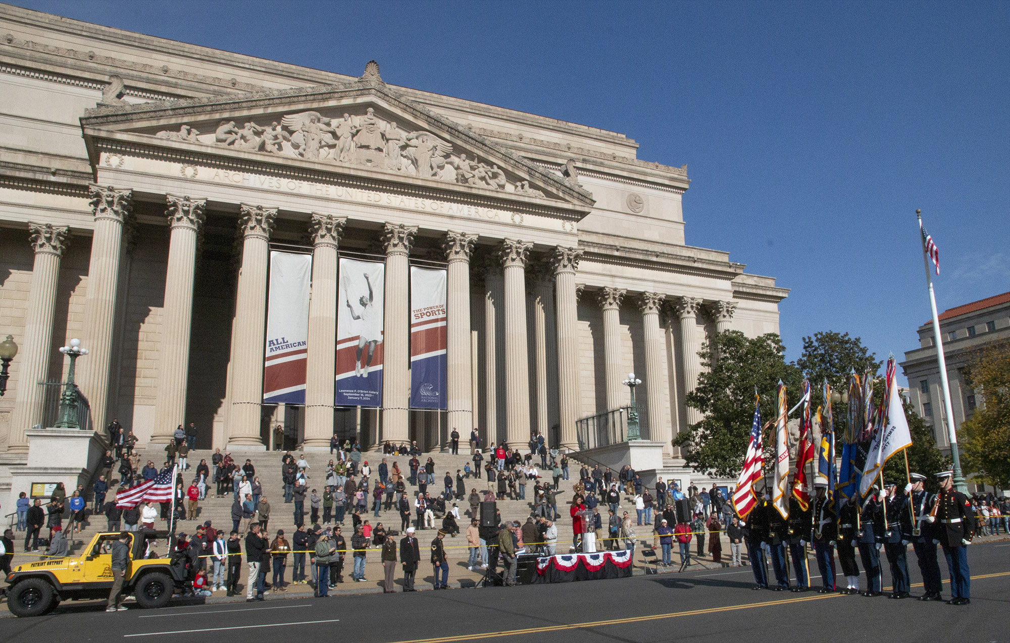

PRICING
Double $1259.00 per person
Single $1539.00 per person

DEPARTURES
AAA, South Williamsport
Quality Inn, New Columbia
AAA, Scranton
Lowes, Stroudsburg
Departure times will be confirmed closer to travel.

NOT INCLUDED
Items of a personal nature
Meals not mentioned
INCLUDED FEATURES & HIGHLIGHTS
- 3 Nights’ Accommodations
- 3 Breakfasts, 1 Lunch, 2 Dinners
- Entry to the Annual Veteran’s Day Parade
- Entry to the Veteran’s Day Celebration at Spirit Park
- Guided tram tour of Arlington National Cemetery
- Entry to Quantico National Cemetery with
Flag-Laying experience
- Visits to the American History Museum and
National Archives
- Visits to numerous Museums of each branch
of the Armed Forces (see itinerary)
- Time at National Harbor with fireworks display
and Tree Lighting Ceremony
- Entry and guided tour of Quantico National Cemetery
- Motorcoach tour and stops at key monuments
- Baggage handling
- Motorcoach transportation
- AAA Host
- Taxes, meal & motorcoach gratuities

Reservations and Cancellations
A $100.00 deposit, per person, is required at the time of making your reservation. If a deposit is not received within 7 days, the reservation will automatically cancel. Final payment is due August 31, 2026. If cancellation should become necessary after final payment, no refund will be due unless your seat can be resold.
Cancellation Insurance is strongly recommended. Ask your travel agent for details.
All prices are based on a minimum number of passengers. If the number falls below that number, the tour may be canceled, or additional costs may apply. Additional fuel surcharges may be imposed at any time by the tour operator, up to and including time of departure that will be the responsibility of the client.

Smoking and Seating Information
No smoking is permitted on the coach. Seats are assigned according to the reception of the reservation. Seats will not be rotated. If you are traveling with another party, require a wheelchair lift, or need to request special seating due a disability, please inform us at the time the reservation is made.

Travel Assistance
AAA regrets that it is not able to provide individual assistance to a tour member for walking, dining or other personal needs. A companion who is capable of and completely responsible for providing it must accompany persons needing such assistance for personal needs.

Guests should consider their physical fitness level and medical history when determining whether this tour is appropriate. Full participation may require extended periods of walking over even and uneven surfaces and steep terrain. There may be steps, inclines, cobblestone surfaces, and extended periods of standing. Participants with physical limitations should take this into account.

Disclaimer of Liability
With respect to the travel arrangements made in connection with this transaction, AAA Travel Agency works with a variety of disclosed principals and independent contractors, including, but not limited to, carriers, cruise lines, transportation companies, tour operators, wholesalers, service companies, hotels, and similar suppliers of travel-related services. AAA Travel agency is not responsible or liable for any acts, omissions, financial stability, delays, changes, use or secure storage of any of your information, personal or otherwise, supplied by you directly or through AAA Travel Agency, by any of the entities of the type listed above. Neither the AAA Travel Agent nor any of its representatives shall be or become liable or responsible for any loss, injury, damage to person, property, or otherwise in connection with any accommodations, transportation, hotel, restaurant, baggage, tour, flight or cruise services resulting directly or indirectly from acts of God, terrorism, social or labor unrest, mechanical or construction failures or difficulties, diseases, bacteria, pathogens, local laws, climatic or weather-related conditions, floods, storms, hurricanes, typhoons, droughts, high or low water levels, criminal acts, fire, breakdown in machinery, acts of governments, de jure or de facto, war, hostilities, civil disturbances, strikes, riots, thefts, epidemics, pandemics, medical quarantines, customs, entry or visa regulations, defaults, delays or cancellations of or changes in itinerary, routing or schedules, from any cause beyond the control of the AAA Travel Agency or from any loss or damage resulting from, missing, lacking, untimely, insufficient or improperly issued passports, visas or other required border-entry documents. Traveler(s) assume complete and full responsibility for checking and verifying any and all passport, visa, vaccination, or other entry requirements of each destination, as well as any and all terms and conditions and restrictions (including, without limitation, fare restrictions) imposed by any carrier, and all safety, health or security conditions at such destinations, during the length of the proposed travel. By embarking upon his/her travel, each traveler voluntarily assumes all risks involved in such travel, whether expected or unexpected. Traveler’s retention of tickets, reservations, or bookings after issuance shall constitute consent to the above, and an agreement on his/her part to convey the contents hereto to all his/her travel companions or group members. The above information is intended to assist you with your travel plans but does not necessarily represent complete and up-to-date travel information for your specific plans.

For reservations, please contact an office below or visit www.aaa.com/appointments.

AAA SCRANTON
570-348-2511

AAA STROUDSBURG
570-421-2500

AAA HONESDALE
570-253-0160
AAA SOUTH WILLIAMSPORT
570-323-8431

AAA WELLSBORO
570-724-4134
AAA TUNKHANNOCK
570-836-5104

AAA TOWANDA
570-265-6122

AAA EAST CENTRAL
570-286-4507

ITINERARY
* This itinerary is subject to change at the tour operator’s discretion without notification and/or compensation.

Day 1 – Friday, November 13
Depart from your hometown and travel to Washington, DC. Visit the National Mall and explore the Smithsonian’s American History Museum. The museum offers a treasure trove of American heritage with an extensive collection of iconic items like the Star-Spangled Banner and the First Ladies' Inaugural Gowns. After self-touring and an independent lunch, depart for the National Archives. The spacious rotunda of the National Archives contains the original Declaration of Independence, Constitution, and the Bill of Rights. For the first time in modern history, all the pages of these documents are on display to the public. This evening, enjoy dinner included before checking into your hotel.
Hotel (3 nts): Hampton Inn & Suites Alexandria Old Town Area South (5821 Richmond Hwy, Alexandria, VA 22303)
Meals included: D

Day 2 – Saturday, November 14
After breakfast at the hotel, meet your local guide in the lobby and depart for Triangle, VA. Visit the Quantico National Cemetery, a 725-acre cemetery for veterans who served in the US Armed Forces. Participate in a Flag-Laying Experience before departing for a tour and lunch on your own at the National Museum of the Marine Corps. A lasting tribute to the US Marines, the Museum’s soaring design evokes the image of the flag-raisers of Iwo Jima. After, depart to explore the National Museum of the US Army. The Museum will celebrate over 240 years of Army history and honor our nation’s Soldiers and provide the only comprehensive portrayal of Army history and traditions and will offer educational experiences to illustrate the Army’s role in building and defending our nation. Following your tour, depart for the National Harbor to stake out your viewing seats for the Veteran’s Day festivities: fireworks and tree-lighting ceremony. Enjoy free time to explore, shop and have dinner on your own before returning to the hotel for the evening.
Meals included: B

Day 3 – Sunday, November 15
Enjoy breakfast at the hotel before departing to meet your guide at Arlington National Cemetery. No land in America is more sacred than this square mile. It is America’s shrine to valor and sacrifice. Experience a tram tour of the grounds and stop at the gravesites of President John F. Kennedy, US Army General John J. Pershing, the Tomb of the Unknown Soldier and the Ord & Weitzel walking gate to see the US Marine Corps War Memorial. Following your tour, depart for the National Archives to claim your seat for the Annual Veteran’s Day Parade! A Monumental Salute to the Veterans honors those who bravely served our country during the past century of our nation's history. A special ceremony takes place in honor of all our war veterans, including WWII, The Korean War, The Vietnam War, The Gulf War and the War on Terror. This historic event will feature veteran speakers as well as choirs and bands from across the country as part of the ceremony. Boxed lunches will be provided. After, attend the Veteran’s Day Celebration at National Harbor’s Spirit Park. The park will welcome a crowd of veterans, first responders and elected officials and dignitaries from throughout the region, to celebrate Veterans Day. Dinner this evening will be included at a local restaurant before returning to the hotel for the evening.
Meals included: B, D
*Please note: All visitors to Arlington National Cemetery 16 years and older must present a valid photo ID upon entering.

Day 4 – Monday, November 16
After breakfast at the hotel, check out and pick up your guide. Enjoy a motorcoach tour of Washington memorials. Stops will include the Air Force Memorial, Marine Corps Memorial, US Navy Memorial Plaza, Vietnam Veterans Memorial, the Lincoln Memorial, Korean War Veterans Memorial and the National WWII Memorial. Following your tour, depart for home with an independent lunch stop enroute.
Meals included: B

