GRP 4556

7-NIGHT PARIS & NORMANDY WINE CRUISE

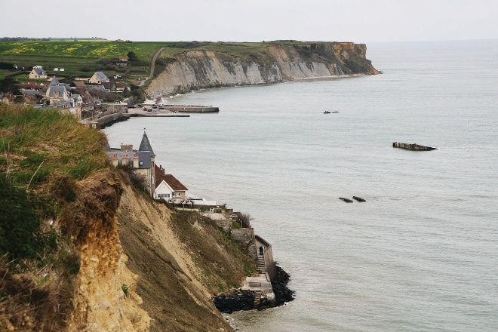
With 1 Pre-night in Paris, France

on the AmaLyra

July 14 – 22, 2027

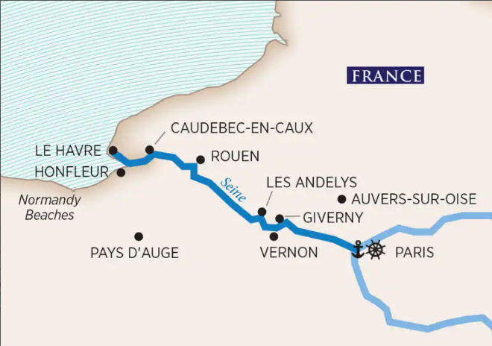
PER PERSON PRICING – CRUISE ONLY1 Double occupancy

RESERVATIONS AND CANCELLATIONS
A $400 per person/$800 per cabin deposit is due to confirm your reservation.
FINAL PAYMENT IS DUE TO AAA BY APRIL 2, 2027.
CRUISE FEATURES2
- Roundtrip transportation to departing airport.
- AAA Host Melanie Palski (based on min number of passengers)
- Pre-night hotel and roundtrip transfers in Paris
- 7-night deluxe river cruise, roundtrip Paris
- All onboard meals including Welcome Reception, Captain’s Gala, quality wines with every dinner, complimentary coffee and tea available throughout the day.
- Sip & Sail Cocktail Hour with complimentary wine, beer and spirits 1 hour prior to dinner.
- Immersive tours in every destination including hiking, biking, special interest, early risers, gentle and active tours.

NOT INCLUDED DEPARTURES Departure times will be confirmed closer to travel.
- Airfare (available September 2026) • AAA, South Williamsport
- Gratuities onboard and to tour guides • Quality Inn, New Columbia
- Meals on land • AAA, Scranton
- Items of personal nature • Lowes, Stroudsburg
- Premium excursions
- Travel insurance
CATEGORY | CABIN TYPE | CABIN SIZE | RATE PER PERSON
E | Fixed Window | 170 sq. ft. | $6,249.00
D | Fixed Window | 170 sq. ft. | $6,585.00
C | French Balcony | 170 sq. ft. | $7,999.00
B | French Balcony | 170 sq. ft. | $8,269.00
A | French Balcony | 170 sq. ft. | $8,369.00
A+ | French Balcony | 225 sq. ft. | $9,335.00
S | Suite, French Balcony | 255 sq. ft. | $9,799.00

CANCELLATION PENALTIES FOR GROUP PRICING

If you make a reservation that is outside of our group contract pricing, different cancellation policies may apply.

Please contact your AAA travel advisor for more information. AIRFARE IS NON-REFUNDABLE AT ALL TIMES.
Deposit date to 121 Days prior to sailing | $200.00 per person
120 to 90 Days prior to sailing | $400.00 per person
89 to 60 Days prior to sailing | 35% of gross fare per person
59 to 31 Days prior to sailing | 50% of gross fare per person
30 to 0 Days prior to sailing | NON-REFUNDABLE

PLEASE NOTE: Effective for travel in 2026 and beyond, all visitors who do not need a visa to enter Europe will be expected to apply for an ETIAS visa waiver for a fee, when visiting a Schengen Area Country. To identify Schengen Area Countries and to complete the ETIAS application, please visit https://travel-europe.europa.eu/etias_en
CRUISE ITINERARY3
Day 1 PARIS, FRANCE Overnight Hotel Free time to explore Paris on your own.

Day 2 PARIS, FRANCE, Embarkation Board the ship in Paris for your Paris & Normandy cruise (D)

Day 3 LES ANDELYS Uncover the history of Château Gaillard, the former stronghold of Richard the Lionheart, situated on the chalk cliffs high above the Seine, on a morning tour. Or, if you prefer a more active adventure, you can hike there from the banks of the Seine, admiring the scenic views along the way. For those who wish to explore the area on two wheels, join a guided bike tour through the charming town of Les Andelys. After your adventures, set sail along the meandering Seine for a scenic cruise. (B,L,D)

Day 4 LE HAVRE During your time in Le Havre, set out on an excursion to the seaside town of Honfleur, renowned for its picturesque harbor, and for being an inspirational site for Impressionist painters. During the afternoon, you can join a city tour of the UNESCO-designated Le Havre. Alternatively, you have the choice of a bike tour through Le Havre. (B,L,D)

Day 5 LE HAVRE – NORMANDY BEACHES – CAUDEBEC EN CAUX Experience the Normandy region with a variety of excursions. For those wishing to go to the American sector of the historic Normandy Beaches, you will visit the cemetery at Colleville-sur-Mer, Omaha Beach, the artillery battery at Longues-sur-Mer and the village of Arromanches, where the remains of the floating harbor used during the WWII landings can be seen. If you prefer, you can tour the Gold and Juno beaches in the British and Canadian sectors, where you will visit Ranville Cemetery, Pegasus Bridge, the Canadian cemetery at Beny-sur-Mer, the WWII museum in Courseulle and, finally, Arromanches. Alternatively, you can set out on a full day excursion to the delicious Pays d’Auge region of Normandy, where apple cider, Calvados and pommeau outrank French wine. In the afternoon, if you wish to experience a different kind of inspiration in Caudebec-en-Caux, you can journey back in time with the interactive exhibits and vessels at the Seine Museum. (B,L,D)

Day 6 ROUEN Spend the morning enjoying medieval Rouen with a choice of several excursions. Join a walking tour and see the square where Joan of Arc was martyred, as well as the Medieval Quarter and Great Clock. You also have the choice to go on the “Tastes of Normandy” tour, where you’ll be treated to the delicious flavors of the region, including chocolate, Norman cheese and cider; or get active by going on a guided bike tour. Then visit Bonnemare Castle, a 16th-century architectural treasure lined with picturesque poplar trees. (B,L,D)

Day 7 VERNON Enjoy scenic cruising around Vernon before disembarking the ship for your excursion. You will have a choice of three excursions, depending on your interests. Visit Claude Monet’s home and gardens in Giverny. Art lovers will immediately recognize images immortalized in Monet’s most beloved paintings—such as water lilies, Japanese bridges and graceful willow trees. Wander around his famous gardens and home where he lived for more than four decades. Or visit the regal 18th-century Château de Bizy, inspired by the opulence of Versailles. Enjoy an escorted tour of the palace and gardens. If you prefer a more active adventure, go on a guided bike tour, taking in the beautiful French countryside. (B,L,D) *PLEASE NOTE: Monet’s Gardens may be closed; therefore an alternative tour will operate instead.

Day 8 PARIS Travel to Auberge Ravoux in the heart of Auvers-sur-Oise, the last home of artist Vincent van Gogh. His spirit still lingers in his former attic rooms at the Ravoux Inn. The mere 70 days Van Gogh spent in Auvers-sur-Oise were astonishingly prolific as he painted more than 70 works here before his death. Or enjoy the exquisite architecture of the Château de Malmaison, the former home of Napoleon and Josephine Bonaparte, also known as "the most beautiful and curious garden in Europe." Active travelers may instead choose to pedal through Paris from the seat of their bike on a guided cycling tour. In the afternoon, experience the “City of Light” from a unique perspective when you board a modern river boat at the Port de la Bourdonnais, located on the banks of the Seine River near the Eiffel Tower. With exterior seating and viewing platforms, your one-hour cruise will be a dream come true as you glide along the river and underneath Paris’s ornate bridges. From the boat, you will take in panoramic views of the city’s iconic buildings and monuments, including the Musee d’Orsay and the Notre Dame Cathedral. (B,L,D)

Day 9 PARIS, FRANCE, Disembarkation Bid farewell to Paris and prepare for your flight home. (B)

For reservations or more information, please contact the AAA North Penn office near you.
HONESDALE 570-253-0160

SCRANTON 570-348-2511
AAA.COM/APPOINTMENTS
SOUTH WILLIAMSPORT 570-323-8431
STROUDSBURG 570-421-2500
TOWANDA 570-265-6122
TUNKHANNOCK 570-836-5104
WELLSBORO 570-724-4134

- Rates are subject to availability at time of booking and include taxes, fees and fuel surcharges which are subject to change and the responsibility of the client.
- Transportation to the pier is based on a minimum number of passengers traveling. If this required number is not met, an additional cost may be pro-rated at the time of final billing.
- Itinerary is subject to change at any time without notification and/or compensation.

PROOF OF CITIZENSHIP

For U.S. Citizens, a Passport (valid for 6 months upon return to the U.S.) is required for this tour. We can assist you with your application for a passport, but please allow sufficient time for the application process. It is the passenger’s responsibility to check the validity of his or her own passport. Failure to provide the correct proof of citizenship will result in denied boarding of the aircraft or cruise ship and no refunds will be issued.

TRAVEL INSURANCE
For your protection AAA recommends travel insurance. Pre-existing medical conditions may be waived with proper coverage if travel insurance is purchased within 14 days of initial deposit only. Other conditions may apply; ask your travel advisor for details. AAA recommends Allianz.

TRAVEL ASSISTANCE
AAA regrets that it is not able to provide individual assistance to a tour member for walking, dining or other personal needs. A companion who is capable of and completely responsible for providing it must accompany persons needing such for personal needs. Guests should consider their physical fitness level and medical history when determining whether this tour is appropriate. Full participation may require extended periods of walking over even and uneven surfaces and steep terrain. There may be steps, inclines, cobblestone surfaces, and extended periods of standing. Participants with physical limitations should take this into account.

DISCLAIMER OF LIABILITY
With respect to the travel arrangements made in connection with this transaction, AAA Travel Agency works with a variety of disclosed principals and independent contractors, including, but not limited to, carriers, cruise lines, transportation companies, tour operators, wholesalers, service companies, hotels, and similar suppliers of travel-related services. AAA Travel agency is not responsible or liable for any acts, omissions, financial stability, delays, changes, use or secure storage of any of your information, personal or otherwise, supplied by you directly or through AAA Travel Agency, by any of the entities of the type listed above. Neither the AAA travel advisor nor any of its representatives shall be or become liable or responsible for any loss, injury, damage to person, property, or otherwise in connection with any accommodations, transportation, hotel, restaurant, baggage, tour, flight or cruise services resulting directly or indirectly from acts of God, terrorism, social or labor unrest, mechanical or construction failures or difficulties, diseases, bacteria, pathogens, local laws, climatic or weather-related conditions, floods, storms, hurricanes, typhoons, droughts, high or low water levels, criminal acts, fire, breakdown in machinery, acts of governments, de jure or de facto, war, hostilities, civil disturbances, strikes, riots, thefts, epidemics, pandemics, medical quarantines, customs, entry or visa regulations, defaults, delays or cancellations of or changes in itinerary, routing or schedules, from any cause beyond the control of the AAA Travel Agency or from any loss or damage resulting from, missing, lacking, untimely, insufficient or improperly issued passports, visas or other required border-entry documents. Traveler(s) assume complete and full responsibility for checking and verifying any and all passport, visa, vaccination, or other entry requirements of each destination, as well as any and all terms and conditions and restrictions (including, without limitation, fare restrictions) imposed by any carrier, and all safety, health or security conditions at such destinations, during the length of the proposed travel. By embarking upon his/her travel, each traveler voluntarily assumes all risks involved in such travel, whether expected or unexpected. Traveler’s retention of tickets, reservations, or bookings after issuance shall constitute consent to the above, and an agreement on his/her part to convey the contents hereto to all his/her travel companions or group members. The above information is intended to assist you with your travel plans but does not necessarily represent complete and up-to-date travel information for your specific plans.

