

**GRP 4514**

7-NIGHT BERMUDA CRUISE



Onboard the Celebrity Silhouette

**Includes**

**Wi-Fi &**

**Drinks!**

June 13 – 20, 2027

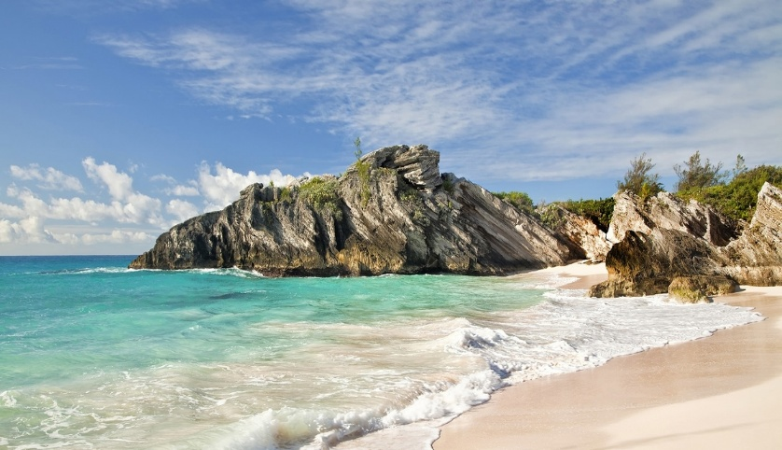**PER PERSON PRICING** Double occupancy.

|  |  |  |
| --- | --- | --- |
| **CATEGORY** | **CABIN TYPE** | **RATE PER PERSON** |
| V2 | Balcony | $2549.00 |
| O2 | Oceanview | $1,999.00 |
| I1 | Interior | $1,869.00 |
|  |  |  |

**CRUISE ITINERARY**

|  |  |  |  |
| --- | --- | --- | --- |
| **DATE** | **PORT** | **ARRIVE** | **DEPART** |
| 6/13 | Cape Liberty, NJ | — | 3:00PM |
| 6/13 | Statue of Liberty Cruising | 4:45 PM | 5:30 PM |
| 6/14 | At Sea | — | — |
| 6/15 | At Sea | — | — |
| 6/16 | Royal Naval Dockyard | 8:30 AM | — |
| 6/17 | Royal Naval Dockyard | — | — |
| 6/18 | Royal Naval Dockyard | — | 4:00 PM |
| 6/19 | At Sea | — | — |
| 6/20 | Cape Liberty, NJ | 7:00 AM |  |
|  |  |  |  |
|  |  |  |  |
|  |  |  |  |

## RESERVATIONS AND CANCELLATIONS

**A $450 per person deposit ($900.00 per cabin) is due to confirm your reservation. FINAL PAYMENT IS DUE TO AAA BY March 1, 2027.**

## DEPARTURES

Departure times will be confirmed closer to travel.

* AAA, South Williamsport
* Quality Inn, New Columbia
* AAA, Scranton
* Lowes, Stroudsburg

**CRUISE FEATURES**

* + Round trip transportation to the cruise pier
  + Seven nights on board Celebrity Silhouette
  + AAA Host (based on min number of passengers)
  + All onboard meals and entertainment (specialty restaurants have nominal fees)
  + Wi-Fi Onboard
  + Classic Beverage Package
  + Baggage Handling

## NOT INCLUDED

* + Gratuities
  + Items of a personal nature
  + Shore Excursions
  + Travel insurance

1. Rates are subject to availability at time of booking and include taxes, fees and fuel surcharges which are subject to change and the responsibility of the client.
2. Itinerary is subject to change at any time without notification and/or compensation.
3. Transportation to the pier is based on a minimum number of passengers traveling. If this required number is not met, an additional cost may be pro-rated at the time of final billing.

##### **CANCELLATION/PENALTIES DAYS PRIOR TO DEPARTURE FOR GROUP PRICING**

**SCAN THE CODE TO LEARN MORE ABOUT NORWEGIAN’S NEWEST SHIP!**

**Norwegian Luna has a variety of accommodations to offer!**

*https://www.ncl.com/cruise/luna*

**SCAN THE CODE TO LEARN MORE ABOUT NORWEGIAN’S NEWEST SHIP!**

**Norwegian Luna has a variety of accommodations to offer!**

*https://www.ncl.com/cruise/luna*

Deposit date to Final Payment Date No Penalty

89 to 75 Days 25% of gross fare per person

74 to 61 Days 50% of gross fare per person

60 to 31 Days 75% of gross fare per person

30 to 0 Days NON-REFUNDABLE

If you make a reservation outside of our group contract pricing, different cancellation policies may apply. Please contact your AAA travel advisor for more nformation.

**M**

## PROOF OF CITIZENSHIP

U.S. citizens on homeport cruises (cruises that begin and end at the same U.S. port) are currently able to enter or depart the country with a state issued birth certificate with a raised seal and government-issued photo ID. AAA recommends traveling with an original, signed passport, valid for 6 months beyond stay. Please contact your travel advisor for other identification options.

## TRAVEL INSURANCE

For your protection AAA recommends travel insurance. Pre-existing medical conditions may be waived with proper coverage if travel insurance is purchased within 14 days of initial deposit only. Other conditions may apply; ask your travel advisor for details. AAA recommends Allianz.

## TRAVEL ASSISTANCE

AAA regrets that it cannot provide individual assistance to a tour member for walking, dining or other personal needs. A companion who is capable of and completely responsible for providing it must accompany persons needing such

for personal needs. Guests should consider their physical fitness level and medical history when determining whether this tour is appropriate. Full participation may require extended periods of walking over even and uneven surfaces and steep terrain. There may be steps, inclines, cobblestone surfaces, and extended periods of standing. Participants with physical limitations should take this into account.

## DISCLAIMER OF LIABILITY

With respect to the travel arrangements made in connection with this transaction, AAA Travel Agency works with a variety of disclosed principals and independent contractors, including, but not limited to, carriers, cruise lines, transportation companies, tour operators, wholesalers, service companies, hotels, and similar suppliers of travel-related services. AAA Travel agency is not responsible or liable for any acts, omissions, financial stability, delays, changes, use or secure storage of any of your information, personal or otherwise, supplied by you directly or through AAA Travel Agency, by any of the entities of the type listed above. Neither the AAA travel advisor nor any of its representatives shall be or become liable or responsible for any loss, injury, damage to person, property, or otherwise in connection with any accommodations, transportation, hotel, restaurant, baggage, tour, flight or cruise services resulting directly or indirectly from acts of God, terrorism, social or labor unrest, mechanical or construction failures or difficulties, diseases, bacteria, pathogens, local laws, climatic or weather-related conditions, floods, storms, hurricanes, typhoons, droughts, high or low water levels, criminal acts, fire, breakdown in machinery, acts of governments, de jure or de facto, war, hostilities, civil disturbances, strikes, riots, thefts, epidemics, pandemics, medical quarantines, customs, entry or visa regulations, defaults, delays or cancellations of or changes in itinerary, routing or schedules, from any cause beyond the control of the AAA Travel Agency or from any loss or damage resulting from, missing, lacking, untimely, insufficient or improperly issued passports, visas or other required border-entry documents. Traveler(s) assume complete and full responsibility for checking and verifying any and all passport, visa, vaccination, or other entry requirements of each destination, as well as any and all terms and conditions and restrictions (including, without limitation, fare restrictions) imposed by any carrier, and all safety, health or security conditions at such destinations, during the length of the proposed travel. By embarking upon his/her travel, each traveler voluntarily assumes all risks involved in such travel, whether expected or unexpected. Traveler’s retention of tickets, reservations, or bookings after issuance shall constitute consent to the above, and an agreement on his/her part to convey the contents hereto to all his/her travel companions or group members. The above information is intended to assist you with your travel plans but does not necessarily represent complete and up-to-date travel information for your specific plans.

## For reservations or more information, please contact the AAA North Penn office near you.

## www.aaa.com/appointments

HONESDALE 570-253-0160

SCRANTON 570-348-2511

SOUTH WILLIAMSPORT 570-323-8431

STROUDSBURG 570-421-2500

TOWANDA 570-265-6122

TUNKHANNOCK 570-836-5104

WELLSBORO 570-724-4134

**SCAN THE CODE TO LEARN MORE ABOUT CELEBRITY’S SILHOUETTE SHIP!**

**The Silhouette has a variety of activities and restaurants to offer!**

[**https://www.celebrity.com/cruise-ships/celebrity-silhouette**](https://www.celebrity.com/cruise-ships/celebrity-silhouette)