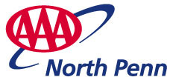
GRP 4458
4461
or 4463
Penn State Football
choose from 3 games!
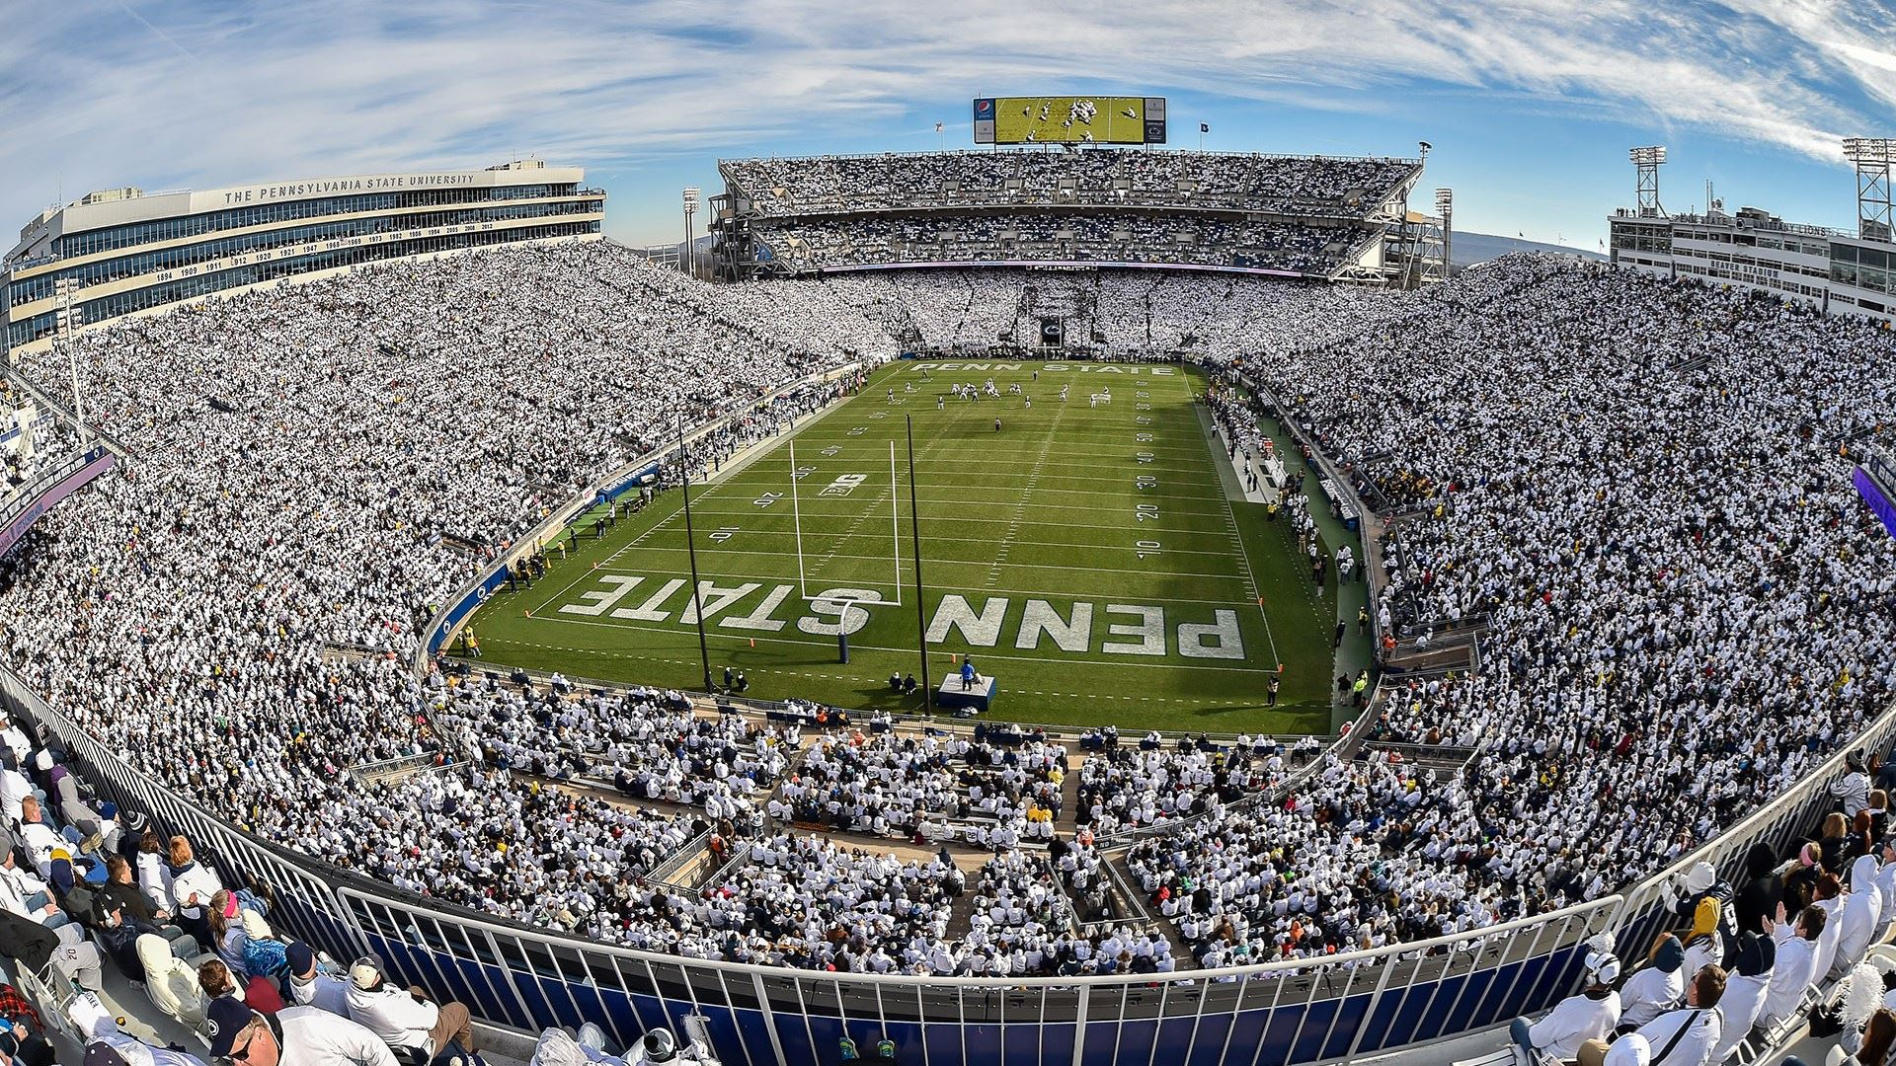

Join AAA Travel for another exciting year of Penn State football! Included is your chosen seat of end zone or sideline section ticket. Kick-off times will be released prior to game day. Don’t miss out on this yearly tradition with AAA Travel!

PRICING (per person, seat chosen when booking)
DATES & OPPONENT END ZONE (NL) SIDELINE (EH)
August 30 vs Nevada $275.00 $295.00
September 27 vs Oregon $295.00 $325.00
November 8 vs Indiana $275.00 $295.00
DEPARTURES
AAA, South Williamsport
Quality Inn, New Columbia
Departure times will be confirmed when kick-off is
announced.
INCLUDED FEATURES
- Roundtrip motorcoach transportation
- Ticket to your chosen Penn State Game
- Boxed lunch by Don Waltman’s Market Place
- Gratuity to motorcoach driver
- AAA Host

NOT INCLUDED
- Items of a personal nature
- Meals not mentioned

Reservations and Cancellations
Payment is due at time of booking. Should cancellation become necessary, no refunds will be issued unless your seat(s) can be resold. No refunds will be given for game cancellations due to weather or other conditions outside the control of AAA North Penn. Cancellation Insurance is strongly recommended. Ask your travel agent for details.
Travel Assistance
AAA regrets that it is not able to provide individual assistance to a tour member for walking, dining or other personal needs. A companion who is capable of and completely responsible for providing it must accompany persons needing such assistance for personal needs. Guests should consider their physical fitness level and medical history when determining whether this tour is appropriate. Full participation may require extended periods of walking over even and uneven surfaces and steep terrain. There may be steps, inclines, cobblestone surfaces, and extended periods of standing. Participants with physical limitations should take this into account.

Smoking and Seating Information
No smoking is permitted on the coach. Seats are assigned according to the reception of the reservation. Seats will not be rotated. If you are traveling with another party, require a wheelchair lift, or need to request special seating due a disability, please inform us at the time the reservation is made.

Responsibility
Our tours are arranged by AAA North Penn who act solely in the capacity of an agent on behalf of its tour patrons in arranging for transportation, lodging, sightseeing and other services and as such cannot be held responsible for any damage, loss, delay, injury, or accident due to any act or default on the part of the company or person engaged in providing transportation, lodging, sightseeing or other services which are part of the tour. Rates quoted are based on tariffs current at the time of printing and are subject to changes on or before time of final payment.
AAA expressly reserves the right to withdraw any tour or make changes in the tour, with or without notice that may become necessary, including substitution of accommodations or transportation. No carrier with whom transportation shall be arranged in connection with these tours shall have or incur any responsibility or liability as a common carrier.
AAA North Penn gives notice that all tickets and coupons are issued or delivered by them and all arrangements for transport or conveyance, or for hotel accommodations, are made by them the agents for passengers upon the express condition that they shall not be liable for any injury, damage, loss, accident, delay or irregularity which may be occasioned either by reason of defect in any vehicle or through the act of default of any company or person engaged in conveying the passenger, or of any hotel proprietor, or employee, or in carrying out the arrangements of the tour, or otherwise in connection therewith. No carrier shall have or incur any responsibility to any person taking this tour except its liability as a common carrier. The airline and/or steamship lines concerned are not conveyances. The passage contract in use by the airline and/or steamship lines concerned when issued shall constitute the sole contract between the carrier and the purchaser and/or passengers of these tours. The aforesaid AAA North Penn can accept no responsibility for losses or additional expenses due to delay or changes of schedule, weather, strikes, war, quarantine or other causes. All such losses or expenses shall have to be borne by the passengers.
All rates and fares shown on this program are based on current tariff at the time of printing and are subject to adjustment in the event of changes therein at the time of final payment. The right is reserved to decline, to accept or to retain any person as a member of any tour or to cancel or alter the tour.

For reservations, please contact an office below or visit
www.aaa.com/appointments.

AAA SOUTH WILLIAMSPORT
570-323-8431

AAA WELLSBORO
570-724-4134

AAA EAST CENTRAL
570-286-4507

